INFORMATION AND FREQUENTLY ASKED QUESTIONS

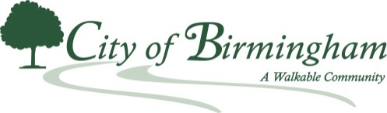
The Michigan Safe Drinking Water Act has changed to better protect your health. New water sampling rules have been added to better detect possible lead in your drinking water. These changes require communities, such as Birmingham, that have a percentage of lead service lines as part of its infrastructure, to do more sampling. This new sampling method is expected to result in higher lead results. It is important to note; Nothing has changed with the City’s water source or quality! What has changed is the sampling procedures and analysis of it, mandated by the new requirements in the Act.
As noted in the City Public Advisory for Drinking Water Customers in the City of Birmingham, the “Action Level” is not a health-based standard, but it is a level that triggers additional actions including, but not limited to, increased investigative sampling of water quality and educational outreach to customers. This is NOT a violation of the Michigan Safe Drinking Water Act. You can find the Public Advisory and other information on the City website at www.bhamgov.org/leadtesting.
The following are answers to some commonly asked questions that are being asked since the City issued its Public Advisory:
Q: Whether I have a lead service line or not, what can I do to reduce my risk?
A: Flushing stagnant water from your home’s plumbing before getting a drink is always a good idea. This is especially important when you’ve been gone for a weekend or taken a vacation and your water hasn’t been used. You can also have the water tested by a private lab from the location in your home that you most likely drink from, often the kitchen tap. You can find a list of state certified labs here: State Certified Labs
In addition, you can purchase a water filter, that typically costs about $35 with replacement cartridges costing about $15. The City has provided complimentary water filters to sites that exceed the new state threshold of 15 ppb (parts per billion). Also, you can purchase from the Oakland County Health Division a water sampling test kit for lead/copper at one their office locations during normal business hours (8:30 a.m.-5:00 p.m.). The address and phone numbers are as follows:
North Oakland Center 1200 N. Telegraph Rd. Pontiac, MI 48341 (248) 858-1280 and
South Oakland Health Center 27725 Greenfield Rd. Southfield, MI (248) 424-7000
The cost of the kits is $24. Additional information can be found on their website at www.oakgov.com/health.
Finally, if you do have a lead service line, you can take these steps to reduce your exposure risks found on this link: https://www.oakgov.com/health/information/Pages/Lead-and-Drinking-Water.aspx.
Q: How do I know if I qualify for a water filter?
A: The Oakland County Health Division provides water filters to disadvantaged members of the public. To qualify for a complimentary water filter from the Oakland County Health Division, your household must have at least one of the following:
- A child under age 18 living there.
- A child under age 18 spending several hours every week at least three months of the year there.
- A pregnant woman living there, AND
- Someone receiving WIC benefits and/or Medicaid insurance.
- Difficulty affording a filter and replacement cartridges (as noted above, filters cost about $35 and replacement cartridges cost about $15.
Q: What is a service line?
A: A service line is a piece of pipe that connects the city’s water main under the street to your home. This connection delivers water to your home. In older homes (typically those built before the 1950’s) this connection can be a lead pipe. If you have a service line that is made of lead, you have an increased risk of having elevated levels of lead in your drinking water. The decision to use a lead pipe at the time the house was constructed was based on the plumber’s decision of that time. It was not based on the location or district that the home was in.
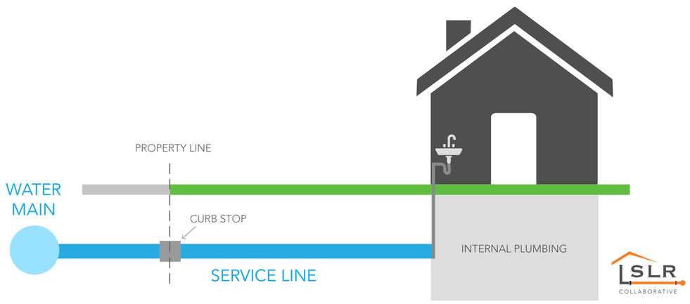

Q: Is there a plan to replace the lead service lines in the City?
A: In accordance with new state rules and for some time now, the City has been gathering information related to the locations of lead service lines in the City. This ongoing work, that in some situations can involve researching decades old records, is on target to meet the deadline of the end of the year. It is also important to note that approximately 780 of the City’s nearly 9,000 water customers have lead service lines.
The City will complete more stringent actions than those required by the State as we address these new rules. We are committed to advancing all required schedules and exceeding future testing and abatement requirements. This will begin in January with the next testing cycle and rather than testing the required 64 properties, we will test all properties in our inventory, which as noted, is approximately 780. From this round of testing we will compile an actionable priority list to begin our abatement program.
Under the new rules, the City is required to replace 7% per year through 2041 beginning in 2021. We will advance our program based on available funding prior to this time. We do not plan to raise water rates for this effort, but rather use existing reserves and participate in cooperative purchasing contracts with other agencies to achieve the best rates for this work.

Q: Can I replace my lead service line on my own?
A: If you want to do the work sooner than what the City plan calls for, at your own expense you can hire an excavator to do this type of work. Typical costs range from $4,000 to $8,000. Many contractors are using sophisticated boring methods to minimize possible damage to your property while the work is being done.
Q: Are the public mains (those under streets or right of ways) made of lead?
A: No. They are made of either ductile iron or cast iron.
Q: Do specific areas or neighborhoods in the City have lead service lines?
A: No. It is all based on individual plumbing and service lines for individual properties in the City. The estimated 780 lead service lines in the City are not specific to a region/area or neighborhood. It is important to note that the City has close to 9,000 water customers with, as mentioned, about 780 having lead service lines.
Q: How is the City addressing the recent sampling results?
A: The City is taking a proactive approach to the situation by continuing to comply with the new state requirements. It is doing so by planning additional testing and sharing information on ways to reduce exposure to lead in your home. In addition, the City is providing complimentary water filters to the households whose lead levels exceeded 15 ppb (parts per billion).
Once the added testing begins, we will be collecting 60 samples from homes known to have a lead service every six months and reviewing the results to determine if corrective actions are necessary to reduce corrosion in household plumbing. The next round of sampling will begin in January 2020. Homes with lead service lines have an increased risk for higher lead levels. Please contact the City’s Engineering Dept. at (248) 530-1840 if you do not know what your service line material is and are interested in having your home inspected. Additional information can be found on the City website at www.bhamgov.org/leadtesting.
Other Resources
State of Michigan
www.michigan.gov/drinkingwater
State Certified Labs
www.Michigan.gov/eglelab
https://www.michigan.gov/documents/deq/deq-odwma-water-cdwu-reduce-lead_524538_7.pdf
https://www.michigan.gov/mileadsafe
Other General Questions
State of Michigan Department of Environment, Great Lakes and Energy (EGLE) 1-800-662-9278
Oakland County Health Division Nurse on Call 1-800-848-5533 Mon.-Fri 8:30 a.m.-5 p.m. or noc@oakgov.com
Important Phone Numbers
Service Line questions City of Birmingham Engineering Dept.
pomeara@bhamgov.org, afletcher@bhamgov.org tbridges@bhamgov.org
(248) 530-1840

Information on getting my property tested City of Birmingham Dept. of Public Services
(248) 530-1700

